

Internal Audit Report

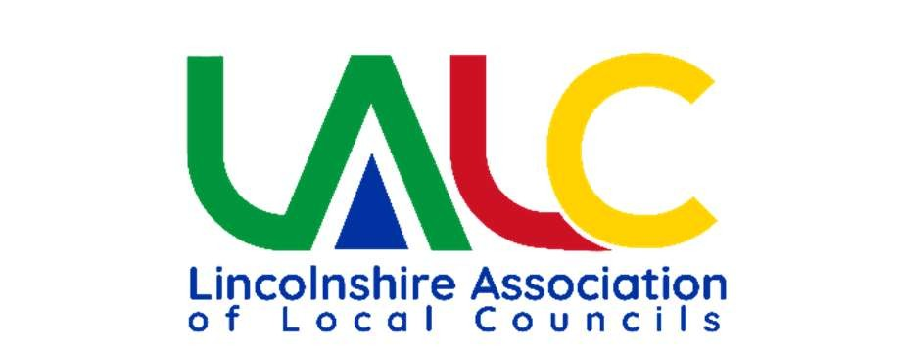

This audit report is to read in conjunction with the Annual Internal Audit Report in the Annual Governance and Accountability Return.

|  |  |
| --- | --- |
| Council: | Willingham by Stow Parish Council |
| Internal Auditor: | Stacey Knowles |
| Year Ending: | March 2025 |
| Date of Report | 21st May 2025 |

Internal audit is the periodic independent review of a council’s internal controls resulting in an assurance report designed to improve the effectiveness and efficiency of the activities and operating procedures under the council’s control. Managing the council’s internal controls should be a day-today function of the council through its staff and management and not left for internal audit. It would be incorrect to view internal audit as the detailed inspection of all records and transactions of a council to detect error or fraud. This report is based on the evidence made available to me and consequently the report is limited to those matters set out below.

The council is required to take appropriate action on all matters raised in reports from internal and external audit and to respond to matters brought to its attention by internal and external audit. Failure to take appropriate action may lead to a qualified audit opinion.

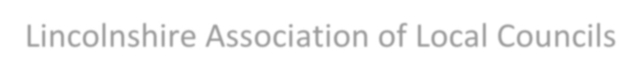

Lincolnshire Association of Local Councils

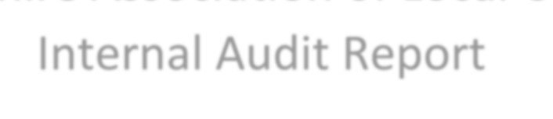

Internal Audit Report



To the Chairman of Willingham by Stow Parish Council

I have examined council business including policies, agendas & minutes, accounting and financial statements and other documents relevant to this audit. Together with the interim audit report dated 6th December 2024, this forms the completed internal audit for the year ending March 2025.

Recommendations made in December 2024:

* The expenditure budget set for 2024-2025 is around £10,000 more than the expected income from burials, precept and available reserves. The clerk explained that this was in respect of projects that the council might undertake but would seek grant funding for. It is recommended that a budget for these projects is not set if the source of income is unknown or conditional. Currently, if the council was to spend the entire 24/25 budget it would be in a deficit. See section 5.28 of the JPAG Practitioners Guide.
* The council should review its general reserves and earmarked reserves at least once annually and minute the amount held against the purposes it is held for. See sections 5.32 to 5.39 of the JPAG Practitioners Guide.

The clerk confirmed that the council had reviewed its reserves in May 2025 and would implement an annual review in future.

The Council continues with good governance practices with a robust audit trail for all transactions.

The Internal Audit section of the AGAR has been completed and signed appropriately. ‘Yes’ responses have been provided for all internal control objections except for internal control objectives F & O which were not applicable to the council.

Thank you to Lisa for meeting with me and accommodating the audit.

Yours sincerely

Stacey Knowles

# Internal Auditor Lincolnshire Association Local Councils Date: 21st May 2025